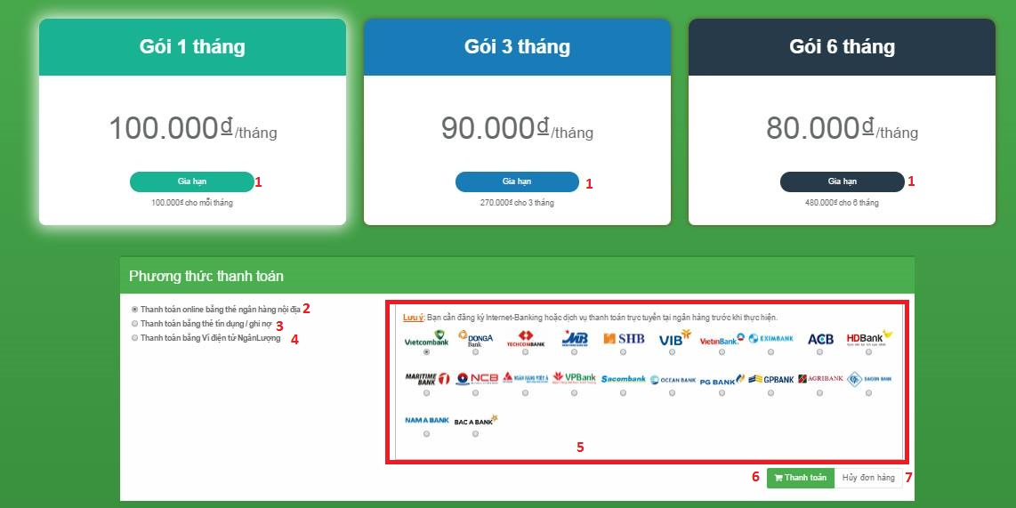

**Fields**:

|  |  |  |  |  |  |  |  |
| --- | --- | --- | --- | --- | --- | --- | --- |
| No. | Field name | Description | Read only | Mandatory | Control type | Data type | Length |
| 5 | Name of Bank | Allow user choose bank which want to payment. | No | Yes | Area radio button | String | N/A |

**Buttons/Hyperlinks:**

|  |  |  |  |  |
| --- | --- | --- | --- | --- |
| No. | Function | Description | Validation | Outcome |
| 1 | Choose type price which want to payment | Show payment methods pop up if click any “Gia hạn” button. | N/A | Show payment methods pop up. |
| 2 | Online payment type | Choose radio button belong to online payment. | N/A | Show banks for online payment. |
| 3 | Credit card payment type | Choose radio button belong to credit card payment. | N/A | Show banks for credit card payment. |
| 4 | Digital wallet payment type | Choose radio button belong to digital wallet payment. | N/A | Show banks for credit digital wallet payment. |
| 6 | Pay | Click “Pay” to redirect “Ngân lượng” page. | N/A | Redirect to “Ngân lượng” website. |
| 7 | Cancel payment | Click “Hủy đơn hàng” to cancel payment. | N/A | Redirect to “Homepage”. |